
UNIVERSITY OF MANAGEMENT AND TECHNOLOGY

ZAREEN SABRI (F2024065491)
SOFTWARE ENGINEERING (W2)

ASSIGNMENT 3

Question 1:
- Construct a Context Diagram showing the system boundary and its interaction with external entities.
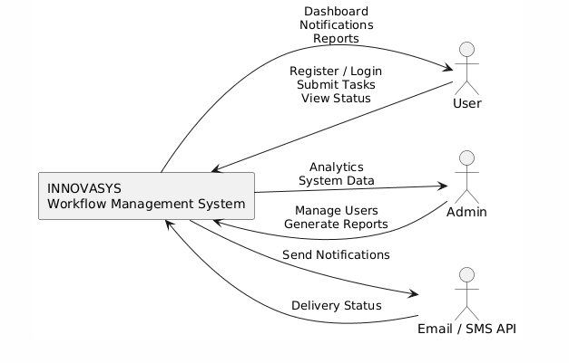
- Convert the Context Diagram into a Data Flow Diagram (DFD) Level 0, identifying the major processes and data flows.
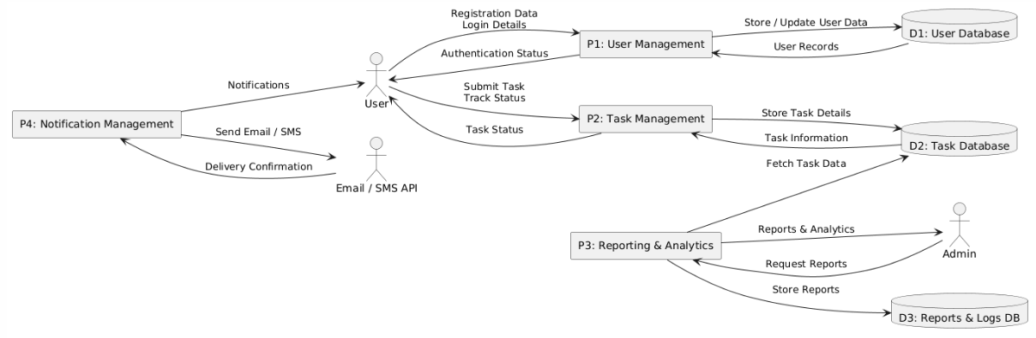
- Draw an Entity Relationship Diagram (ERD) representing the system’s data entities and their relationships.
